**Pambula Surf Life Saving Club**

**NIPPERS**

[nippers@pambulasurf.org.au](mailto:nippers@pambulasurf.org.au)

**Junior Surf Life Saving**

**Handbook**

**2024-2025 Season**

## **PAMBULA SLSC**

Welcome to the 2024-2025 Nipper season at Pambula SLSC. Welcome to our new members and welcome back to familiar faces.

As a club, we’re sure that this season will be as successful as last year, and we look forward to watching our Nippers develop into junior surf lifesavers throughout the year. Last season, our Nippers had a great time and improved their skills during our Sunday activities and a number competed well at the Branch carnivals. It is hoped that this year will be no different.

The Junior Sub-Committee, responsible for organising Nipper activities, consists of parents like you. Most committee members have children who either are Nippers or have been in the past so they have first-hand knowledge of being a Nipper parent and can help with any queries you may have. We strongly believe in the value of surf education and the wellbeing of our children at the beach and look forward to a great season.

Find more information under the Nippers tab on the new club website: <https://www.pambulasurfclub.com.au/>

**Pambula SLSC Junior Sub-Committee**

Contact Nippers: [nippers@pambulasurf.org.au](mailto:nippers@pambulasurf.org.au)

Junior Activity Chair: Lauren Moreland

Junior Activity Secretary: Cathleen Dabros

Water Safety Coordinator: John Grady

Age Manager Coordinator: Jo Stubbings

BBQ Coordinator: Victoria and Dean Mansfield

Uniforms Coordinator: Eleanor Farris

## **HISTORY**

Pambula SLSC has a very proud history, with the club celebrating 100 years in 2014.

Also, Pambula is the original home of Nippers. We were the first club ever in Australia to have Nippers. Surf Education will tell you some stories about our history and about some of the lives that have been saved at Pambula Beach.

## **WHY JUNIOR SURF LIFESAVING?**

Junior surf lifesaving (Nippers) is one of the fundamental areas of the lifesaving movement.

Being a member of Pambula SLSC allows your child to have an identity within Surf Lifesaving Australia and know that they are part of a great national tradition that is identified worldwide.

Our club offers every child an opportunity to develop confidence and skills in and out of the water with the added bonus of having fun along the way.

Nippers are often seen as being for those kids that are good at swimming and surfing**, this is not the case**. It is vitally important that all children have knowledge of the hidden dangers of our beaches. During the season every child is shown (in a way that they are able to understand) a little about the dangers of the surf and ways to avoid getting into difficulties in and out of the water. This is part of the National Surf Education Program. It is an ideal way of introducing inexperienced and frightened children to the surf environment.

## **WHAT HAPPENS AT NIPPERS?**

There are set activities and events for all Nippers to participate in each week. They are designed to be age-appropriate and combine team cooperation, knowledge of the beach and surf, as well as physical skills. The knowledge and skills learnt at Nippers are **skills for life**.

Children who are able to complete the pool water proficiency (see below) can enjoy activities including **swimming in the surf, board paddling, board and tube rescues etc.**

For those who aren’t yet ready to obtain their water proficiency there are beach-based activities to participate in until they gain the necessary skills and confidence for water-based activities. Beach activities include Beach Sprints, Beach Relays, Flags, Wades, Surf Education (theory), March Past, and other fun activities.

Children are also encouraged to achieve Junior Surf Lifesaving Awards. **Surf Education** is a series of graded activities that aim to teach children the basic facts about the beach, the water and the environment. The program covers **Surf Awareness, Surf Safety, Surf Smart and Surf Rescue.**

Nippers can also **compete in carnivals** against their peers from other clubs, should they wish. Competition is encouraged but **not compulsory**. Nippers must pass the **surf proficiency** (see below) to be eligible to compete in carnivals.

**Nippers is run by volunteers. Parents/Guardians are encouraged to participate in the running of Nipper activities as a part of your child’s involvement.**

Finally, if you have any queries or questions, please do not hesitate to contact the Junior Coordinator or any Committee member of the club.

## **IMPORTANT INFORMATION**

* Please see below for the swim requirements to participate in Nippers.
* **It is strongly advised that ALL Nippers bring a wetsuit** as they will be in and out of the water for extended periods and conditions can turn cold any time of year. This could impact greatly on your child’s enjoyment of Nippers. Please also bring Nipper cap, hat, sunscreen, drink, towel, and change of clothes (optional).
* **It is compulsory for the club cap & fluro vests to be worn at all times whilst on Pambula Beach at Nippers or at carnivals. This is a safety requirement.** These can be purchased from the club.
* A child must have passed the **Carnival** qualification (see below) in their age group before they can compete at any carnival.
* A minimum of **one parent/guardian per child/family** must be present during Nippers in case of illness or injury.

## **SCHEDULE**

Nippers is held Sunday mornings between 9:30 am and 12 noon. **Please arrive on time to allow for a prompt start**.

The children will participate in a program that will teach your child specific skills that will enable them to enjoy the surf & sand and if they choose, enjoy competing at Surf Carnivals up and down the coast.

## **WATER SAFETY**

Qualified Lifesavers ensure your child is safe during water activities. They accompany children during ocean swims and board paddling and carry floatation devices. An inflatable rescue boat (IRB) also sits outside of the surf break as an additional safety measure. Should your child get into difficulty, Water Safety personnel will help him/her. No child is placed in danger.

## **AGE MANAGERS (AGE ASSISTANTS)**

Age Managers and Assistants is the term used interchangeably for the supervising adult/s of each age group. Age Mangers and Assistants are integral to the delivery of the Nipper program.

Age Managers guide and supervise the Nippers in their group between activities. To ensure we have a large resource pool from which to draw, we encourage all able Nipper parents/carers to become Age Mangers.

To become an Age Manager a short, online course needs to be undertaken along with obtaining a Working With Children Check.

Age Managers Course: Log in to your member are of sls.com.au > eLearning > log in to eLearning > training library > Age Managers – training courses:

* SLS – Child Safety Awareness (do first)
* SLS – Age Managers

Obtain Working With Children Check (WWCC) <https://www.service.nsw.gov.au/transaction/apply-working-children-check> It is free for volunteers. **Please forward your WWCC details to our Nipper email address.**

## **JUNIOR PARTICIPATION POOL SKILLS EVALUATION (NIPPERS REQUIREMENT)**

## **Sapphire Aquatic Centre, Pambula Sat 26th and Sunday 27th October. Times TBC**

Nippers should come to the pool on either date during the scheduled time. There is NO CHARGE for this proficiency swim. Each Nipper MUST have had their pool skills evaluated before they can participate in water activities.

Proficiency will be assessed as follows:

|  |  |
| --- | --- |
| **Under 8** | 25 metre swim (any stroke)  1 minute survival float |
| **Under 9** | 25 metre swim (any stroke)  1 minute survival float. |
| **Under 10** | 25 metre swim (any stroke)  1.5 minutes survival float |
| **Under 11** | 50 metre swim (any stroke)  2 minutes survival float |
| **Under 12** | 100 metre swim (any stroke)  2 minutes survival float |
| **Under 13** | 150 metre swim (any stroke)  3 minutes survival float |
| **Under 14** | 200 metre swim (any stroke)  3 minutes survival float |

## **Junior Competition Surf Qualification (for carnival only)**

## **Assessment will be conducted during the normal Nippers weekly program**

|  |  |
| --- | --- |
| **Under 8** | NIL (no water competition, except for wade which takes place in waist-deep water) |
| **Under 9** | Minimum 150m open water swim (any recognised stroke) |
| **Under 10** | Minimum 150m open water swim (any recognised stroke) |
| **Under 11** | Minimum 200m open water swim (any recognised stroke) |
| **Under 12** | Minimum 200m open water swim (any recognised stroke) |
| **Under 13** | Minimum 200m open water swim (any recognised stroke) |
| **Under 14** | Minimum 200m open water swim (any recognised stroke) |

## **AGE GROUPS**

Age groups for 2025-2025:

|  |  |  |  |  |  |  |  |  |  |
| --- | --- | --- | --- | --- | --- | --- | --- | --- | --- |
| **Month/Year of Birth** | **2010** | **2011** | **2012** | **2013** | **2014** | **2015** | **2016** | **2017** | **2018+** |
| **January** | too old | U14 | U13 | U12 | U11 | U10 | U9 | U8 | Buckets |
| **February** | too old | U14 | U13 | U12 | U11 | U10 | U9 | U8 | Buckets |
| **March** | too old | U14 | U13 | U12 | U11 | U10 | U9 | U8 | Buckets |
| **April** | too old | U14 | U13 | U12 | U11 | U10 | U9 | U8 | Buckets |
| **May** | too old | U14 | U13 | U12 | U11 | U10 | U9 | U8 | Buckets |
| **June** | too old | U14 | U13 | U12 | U11 | U10 | U9 | U8 | Buckets |
| **July** | too old | U14 | U13 | U12 | U11 | U10 | U9 | U8 | Buckets |
| **August** | too old | U14 | U13 | U12 | U11 | U10 | U9 | U8 | Buckets |
| **September** | too old | U14 | U13 | U12 | U11 | U10 | U9 | U8 | Buckets |
| **October** | U14 | U13 | U12 | U11 | U10 | U9 | U8 | Buckets | Buckets |
| **November** | U14 | U13 | U12 | U11 | U10 | U9 | U8 | Buckets | Buckets |
| **December** | U14 | U13 | U12 | U11 | U10 | U9 | U8 | Buckets | Buckets |

Under 6 & under 7 year old children may participate in a Nippers program called “Bucket Brigade”. Here they have fun on the beach, and in shallow water, taking part in organised activities. No surf lifesaving club is permitted to accept membership of a child until they reach 5 years of age.

## 

## **MEMBERSHIP FEES**

Adult (Associate member) $100

Adult (Active member) $0 (this year only)

Individual child (Nippers) $40

Family Registration $180

Note: Every Nipper must have at least **one adult member** (Associate or Active). To join the club or renew, go to [https://members.sls.com.au/SLSA_Online/modules/login/index.php](https://members.sls.com.au/SLSA_Online/modules/login/index.php%20)

## **CLUB UNIFORMS**

**IT IS COMPULSORY TO WEAR A NIPPER’S CAP & HI VIS FLUORO VESTS AT NIPPERS EACH WEEK AND AT CARNIVALS FOR SAFETY.** These and other club clothes items including hooded towels, swimmers and hats can be purchased at Nippers.

**Note: Buckets are provided with a cap each week. Purchase of a club cap is not required until in the Nippers program (U8)**

**Nippers starts at 9:30am for 9:45am on the beach warm up and 10am sharp start.**

**3 parents per age group needed each week to help with the BBQ per the roster.**

|  |  |  |  |  |  |
| --- | --- | --- | --- | --- | --- |
| **DAY** | **DATE** | | **DETAILS** | **LOCATION** | **BBQ ROSTER** |
|  | |
| Sunday | 3 Nov 2024 | | Nippers | PSLSC | U14 |
| Sunday | 10 Nov 2024 | | Nippers | PSLSC | U13 |
| Sunday | 17 Nov 2024 | | Nippers | PSLSC | U12 |
| Sunday | 24 Nov 2024 | | Nippers | PSLSC | U11 |
| Sunday | 1 Dec 2024 | | Nippers | PSLSC | U10 |
| **Saturday** | 7 Dec 2024 | | Christmas Twilight Nippers | PSLSC | U9 |
| Sunday | 15 Dec 2024 | | CARNIVAL | NAROOMA |  |
| Sunday | 22 Dec 2024 | | HOLIDAYS |  |  |
| Sunday | 29 Dec 2024 | | HOLIDAYS |  |  |
| Sunday | 5 Jan 2025 | | HOLIDAYS |  |  |
| Sunday | 12 Jan 2025 | | HOLIDAYS |  |  |
| Sunday | 19 Jan 2025 | | HOLIDAYS |  |  |
| **Saturday** | 25 Jan 2025 | | Nippers | PSLSC | U8 |
| Sunday | 2 Feb 2025 | | Nippers | PSLSC | U14 |
| **Saturday** | 8 Feb 2025 | | CARNIVAL | BROULEE |  |
| Sunday | 16 Feb 2025 | | Nippers | PSLSC | U13 |
| Sunday | 23 Feb 2025 | | Nippers | PSLSC | U12 |
| **Saturday** | 1 March 2025 | | CARNIVAL | PAMBULA | Branch Champs |
| Sunday | 9 March 2025 | | Nippers | PSLSC | U11 |
| Sunday | 16 March 2025 | | Nippers | PSLSC | U10 |
| Sunday | 23 March 2025 | | Nippers | PSLSC | U9 |
| Sunday | 30 March 2025 | | Nippers | PSLSC | U8 |
| Sunday | 6 April 2025 | | Brats vs Adults | PSLSC | Any |

THANKS TO OUR SPONSORS

|  |  |
| --- | --- |
| Capital Chemist Wanniassa | Little Nippers Logo |

## **CARNIVALS**

Carnivals are an optional activity for all Nippers. They require preparation, planning and time. The benefits for each Nipper attending carnivals can be great with team and individual rewards increasing self-esteem.

The Nippers Season Program lists the local FSC Branch carnivals for this season. We normally setup our own club tent and supply all boards and equipment to the children within our club. The club pays for the carnival registration fees.

Each year there are NSW Country Championships and a NSW State carnival held with thousands of competitors. **Any** Nipper or Senior (bronze) can attend these. If you think your child would like to be involved, please speak with his/her Age Manager or the President.

Please note that to participate in carnivals your child must pass the competition ocean swim distances as per surf lifesaving requirements detailed in this booklet. Events that your child can participate in during a carnival include:

• March Past

• Surf Races (body surfing, wading, sprinting)

• Cameron Relay (team of 4:1xSwimmer, 2xrunners, 1xboard paddler)

• Board Races and Board Rescue (1xswimmer, 1x board paddler)

• Iron Man/Woman (swim, board and sprint)

• Flags

• Beach Sprints

• Beach Relay (team of 4)

• Novelty events

## **NIPPER AWARDS**

Nippers will be acknowledged for their achievements at the end of season presentation. Various awards will be presented. These awards will include but will not be limited to:

• Age Champion

• Encouragement Award

• Achievement Award (All Nipper)

• Most Improved in Water

• Brave Heart Award

Age Champion awards have a set number of criteria which includes attendance and participation at Sunday Nippers, carnival participation and results, and overall attitude. Further information regarding these criteria can be obtained from Age Managers.

## **CODES OF CONDUCT**

### **KIDS CODE**

1. Play to enjoy the sport

2. Follow the rules

3. Do not throw sand, it can be dangerous

4. Do not argue with official’s decisions. In a carnival situation, the team manager can ask the   
necessary questions

5. Try to control your temper and be a good sport

6. Treat other Nippers as you like to be treated

7. Remember the aim is to have fun and improve your ability

8. Always stay with your age group

9. Nipper caps must be worn at all times

10. Listen to your Age Manager and teammates

11. Competing is most important, winning is a bonus

Note: Because of the risk of disrupting and endangering others in the age group, any Nipper who does not follow the above code may be asked to leave the beach on the day.

**NO BULLYING WILL BE TOLERATED.**

### **PARENT/GUARDIANS CODE**

1. Ensure your children understand the Kids Code

2. Be present on the beach at all times

3. Do not make an unwilling child participate

4. Children are involved in sport for their enjoyment, not yours. Don’t spoil it by being too intense

5. Encourage effort, it is as important as the result

6. Work towards improving skills and sportsmanship

7. Do not yell and abuse a child for making a mistake. They are trying as hard as they can

8. Do not publicly question an official’s decision

9. Be on your guard against projecting your own aspirations onto your child

10. Recognise the value and importance of volunteer coaches.

### **SPECTATORS CODE**

1. Applaud good efforts by your own team and their opponents

2. Show respect for your team’s opponents. Without them there would be no competition

3. Condemn the use of violence in all forms

4. Respect ALL decisions made by the officials

5. Encourage competitors to always play according to the rules

6. Do not swear or harass competitors, coaches or officials.

## **SUNSMART POLICY**

**SLIP** on a t-shirt with a high neck, sleeves to the elbow and one that you can’t see through.

**SLOP** on sunscreen minimum of factor 30+ and one that is water proof. It must be applied 15 minutes before going into the water!

**SLAP** on a hat. The best type is one with a broad rim.

**WRAP** on some sunnies, with a 100% UV filter.

**Please remember to take some water on the beach with you!**

**PLEASE BRING A WETSUIT AS THE CHILDREN WILL BE IN AND OUT OF THE WATER FOR AN EXTENDED PERIOD.**

## **PHOTOGRAPHS OF NIPPERS ACTIVITIES**

Pambula Surf Life Saving Club may take and use of photographs of Nippers activities for the Club website, Club media purposes and the Club Facebook page. Consent to images being taken of you or your child is given at the point of registration. Please be aware there is no longer the option to ‘opt out’.

The Club is committed to child safety and will only take and use images that are appropriate for the purposes of the Clubs pursuits.

We ask you when taking photos during the Nippers program to be mindful others and avoiding taking images of children of which you are not the guardian. Please also be aware of child safety laws concerning the taking and use of images of minors.

## **PARENTAL INVOLVEMENT**

Parental/caregiver involvement in any club, in any sport is vital to its success and our club is no different. We rely heavily on the cooperation, help and patience of all parents (see also Child Protection Policy below).

Parents/caregivers will be asked to please **commit to volunteering** regularly during the season as part of their child’s membership. Tasks **will be rostered** and may include acting as an Age Manager or Age Manager stand-in, setting up and packing away gear, helping with the BBQ, Carnival Official etc.

Parents/caregivers are also encouraged to gain their Bronze Medallion to allow them to act as a Water Safety Officers. Other surf lifesaving awards such as first aid, advanced resuscitation or radio operator may also be of interest.

It is **compulsory** all parents / caregivers remain on the beach throughout Nippers. This ensures that the child’s Age Manager knows who they have in their care and can find a parent should they need to contact them for any reason. Parents/caregivers MUST accompany their child to their respective age group outside the clubhouse at the start of Nippers each week.

## **CHILD PROTECTION POLICY**

The *Child Protection (Working with Children) Act 2012* and the *Child Protection (Working with Children) Regulation 2013* require that a Working With Children Check (WWCC) is now a prerequisite for anyone in child-related roles, either paid or voluntary.

Although there are some exemptions for the WWCC for volunteers include children (under the age of 18) and parents or close relatives volunteering with a team, program or other activity in which their child usually participates or is a team member, **the club requests all volunteers in direct contact with children hold a current WWCC.**

For more information see the NSW SLS WWCC Guidelines <https://www.surflifesaving.com.au/resources/working-children-check-requirements-2021>

To obtain a WWCC, or to renew, simply complete the online verification at: <https://www.kidsguardian.nsw.gov.au/child-safe-organisations/working-with-children-check>

Take the Application Number provided along with your proof of identity to a Roads and Maritime Services registry (RMS). The RMS will email a WWCC Number in due course. You will need to provide this WWCC Number, full name and date of birth to the PSLSC to [WWCC@pambulasurf.org.au](mailto:WWCC@pambulasurf.org.au).

## **AGE MANAGERS & AGE ASSISSTANTS**

The support of parents is essential to the success of every Nippers season and the rewarding role of Age Manager & Age Assistants is a large part of this support. An Age Manager/Assistant supports in the conduct of Nippers by being responsible for an age group and helps make the junior surf lifesaving experience fun, safe and challenging.

An Age Manager is responsible for the age group’s safety and well-being during Nippers, initiating and maintaining attendance sheets for the age group and monitoring the efforts of children. Working with the Nippers organisers, water safety and coaches they are asked to help instil enjoyment and fun in what the children do and be a positive role model.

The pre-requisites to be an Age Manager are:

* Be a current financial member of the club
* Have completed the NSW Working with Children Check (WWCC) (U18 and parents/guardians of   
  Nippers are exempt from WWCC requirements), and
* Have completed the Age Managers Course:
* Log in to your member are of sls.com.au > eLearning > log in to eLearning > training library > Age Managers – training courses:
* SLS – Child Safety Awareness (do first)
* SLS – Age Managers
* Be a minimum age of 16 years.
* **You do not need your Bronze Medallion to be an Age Manager**

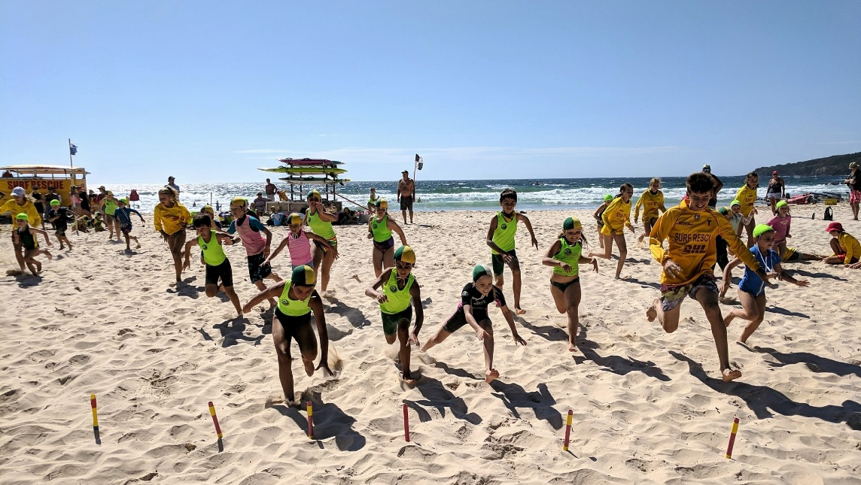

|  |  |
| --- | --- |
| cid:83891965-F9FE-48CC-8C44-5772F87D5BC9 | cid:D787AD69-5939-48EC-B685-7A179A5918AD |

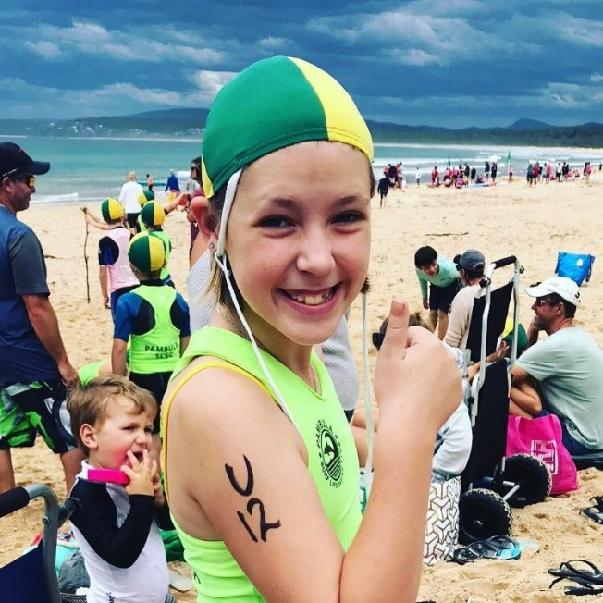

**Online Registration Troubleshooting Guide 2024**

# Registration Information for Members

### A guide to online registrations.

## New Members

#### For Nippers and Members under 18

You will need to make a payment. Your child’s birth certificate may need to be sighted on the first day of nippers.

* **The Pambula club you are joining requires a parent / carer to join with a nipper. You will need to sign up online as a FAMILY, the system pre-fills the address etc. for all family members. (Although you can choose to pay in the most cost-effective way. E.g., if you are joining one nipper and one parent, it is better to pay as an adult plus a junior, which is $140, as opposed to a Family membership, which is $180. If you are joining 2 adults and 2 juniors, then the Family membership is more cost effective. Please refer to the Membership Price List for the relevant membership fees.)**

#### For Adults

You will need to make a payment and show some form of ID to the trainer when onsite if you are signing up for a course.

Options available:

* Join as an individual – select ‘An Individual’ and follow the prompts
* Join as a family – select ‘My family’. Many clubs require a parent/carer to join as well as their child. **The first person to sign up must be over 18.** Fill in the required details and then add a new member to sign up your child. Keep adding new members to the family group if you have more than one child.

***Note:*** If the system comes up with the following, it means that you have previously been a member at another surf club. (This often happens if adults are joining and maybe did a short time in nippers as children or were a member in another state):

In this instance follow the directions or contact the club for assistance.

## Still having trouble?

For a comprehensive guide on how to join a Surf Club, click on the link below:

<https://www.manula.com/manuals/surf-life-saving-australi/join/1/en/topic/accessing-join>

**Please note: You will need to present your child’s birth certificate (copy or photo will suffice) on the first day of nippers. You will need to provide photo ID to your trainer if you are undertaking a SLS course.**

## Renewing Members

### Before you start

Make sure you have any Active Kids vouchers (if using) and a payment method (Credit/debit card) before you renew your membership.

### Getting started

You need a members portal account to renew your membership. Go to the members portal at the link below:

[MEMBERS PORTAL](https://members.sls.com.au/SLSA_Online/modules/login/index.php)

If you haven’t got an account, follow the prompts to create one. If you have forgotten your username or password, follow the prompts. *You will need the exact name and email address you originally registered with.*

Once you have set up a members account, you will need to activate it here.

Click here and then follow the prompts. Make sure you use the exact name and email you originally registered with

### To Renew

Once you have logged into your members portal, go to Memberships in the top menu bar.

#### From the drop downs:

### For Individual renewals:

1. Select Renewals, payments, transfers.
2. Check your details are correct and follow the prompts to renew.
3. The membership fees will show on the payment page. **You will need to check the correct fee and manually put the amount in.**
4. Make your payment.
5. Your renewal will go into pending for your club administration to endorse.

### For family renewals:

1. Select Family
2. Select who you want to renew and follow the prompts.
3. The membership fees will show on the payment page. You will need to check the correct fee you need to pay and manually put the amount in. *Note: If you are using active kids vouchers, the system will calculate any difference owed in the payment page.*
4. Make your payment
5. Your renewal will go into pending for your club administration to endorse.
6. It’s a good idea to log into your members portal after renewing and check the contact details are correct.

If you are still having trouble renewing your registration, contact your club administration for assistance.

Marci

[Registrar@pambulasurf.org.au](mailto:Registrar@pambulasurf.org.au)

Mobile: 0459258080